FAI: Femoroacetabular Impingement and Hip Arthroscopy
Understanding Your Options
J. Michael Smith, MD

What is it?
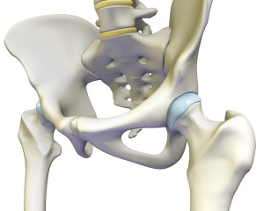
- The normal hip is a highly congruent ball and socket joint
- FAI occurs when there is a structural mismatch between the ball (femur) and the socket (acetabulum)
- Abnormal contact (impingement) at extremes of hip range of motion leads to dysfunction and damage
- Small deformity may become symptomatic with high-level activities while symptoms with routine activities may occur with larger deformities or more advanced damage
- damage usually the result of cumulative effects of repetitive abnormal contact
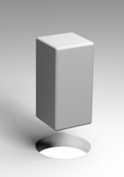
Types of FAI
- Cam Impingement
  - The ball (femoral head) is not completely round
  - May be a prominent bump or the ball may be elliptical in shape
  - Damage occurs when the out-of-round area of the ball rotates into the round socket (square peg in a round hole)
  - Pain occurs with hip flexion, inward rotation, squats, etc.
  - More common in men
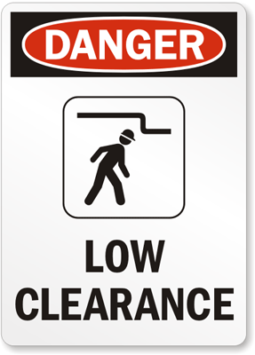
- Pincer Impingement
  - Overhanging rim of socket decreases clearance during hip motion
  - May be caused by a socket that is too deep or not facing forward (retroversion)
  - Damage occurs when the neck collides with the rim of socket
  - Pain with hip flexion, stairs, abduction, etc.
  - More common in women
- Mixed or Combined: elements of both cam and pincer FAI

Management
- Key concepts to consider:
  - FAI is a dynamic problem…. it occurs because the hip is under stress from the activities to which it is exposed
  - A high percentage of people have hips that would meet X-ray criteria for FAI, but only a small percentage become symptomatic, and an even smaller percentage require intervention
  - High percentage of people with FAI have similar findings on the other hip but do not have symptoms
- Goal of management is returning the hip to the pre-symptomatic state by reducing inflammation and optimizing the mechanics around the pelvis
- Rest and avoiding the inciting activity will improve symptoms and allow healing
- Anti-inflammatory medicines (ibuprofen, naproxen, etc.) decrease swelling and inflammation
- A cortisone injection may help to calm inflammation in the joint
- Physical therapy is essential to improving pelvic mechanics and stabilizing gait
- Most cases of FAI improve without surgery

Arthroscopic Surgery for FAI
- Goal is to correct the bony abnormality underlying the impingement
- small (4 mm) video camera inserted into the hip joint and highly specialized instruments are used to perform surgery
- Traction is required to separate ball from socket
- Cam FAI – the ball is is made more spherical to improve congruity
- Pincer FAI – the rim is trimmed to increase clearance
- Secondary damage (labral tears, cartilage damage) fixed or cleaned up
- Recovery takes 4 to 6 months and requires rigorous therapy to restore hip function
- Potential complications include traction-related injury, nerve damage, progression of labral tearing and/or arthritis, abnormal bone formation in muscles around the hip, blood clots, incomplete correction, and residual pain
Cam correction  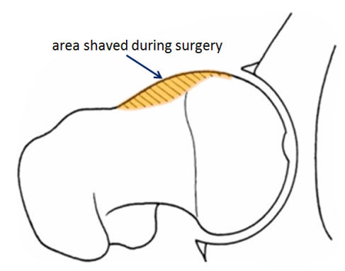  ⋆ | 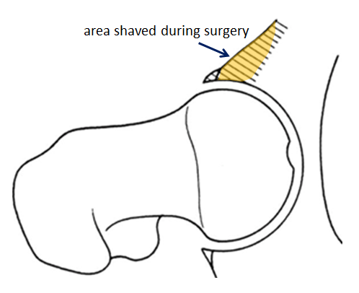  Pincer correction  ⋆

